FUNCTIONAL REQUIREMENTS & WIREFRAME SPECIFICATION REPORT - VINFAST VEHICLE RENTAL SYSTEM
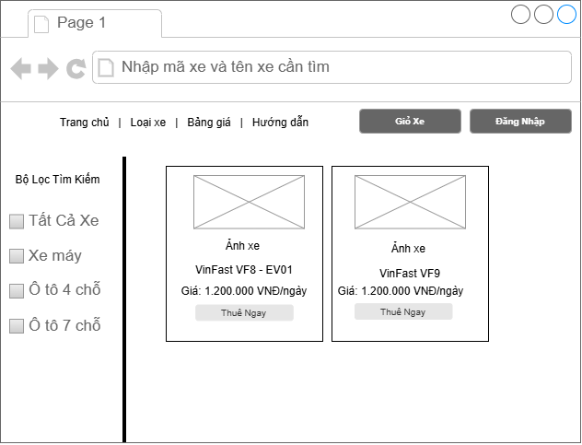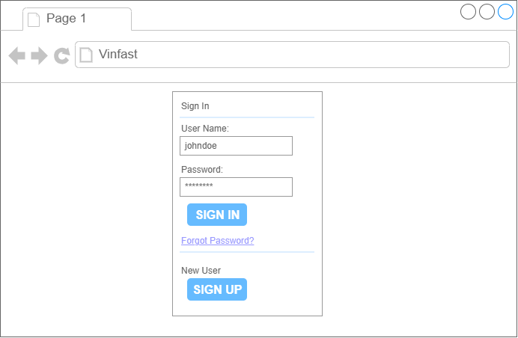Functional Description:
- FR-01 (Display Vehicle List): The interface displays a catalog of VinFast electric vehicles (such as VF8 cars, Feliz S e-scooters) using a product card layout, showing thumbnail images, vehicle names, and daily rental rates.
- FR-02 (Vehicle Search): A search bar enables users to enter vehicle IDs or vehicle names for instant filtering.
- FR-03 (Filter and Category): Category filters (Electric Cars vs. Electric Scooters) and price ranges help customers easily find vehicles matching their specific needs.
- FR-04 (User Authentication and Navigation):
  - The top navigation bar provides quick access to Home, Pricing, and User Guide sections.
  - A Login / Register button is integrated on the top right. Clicking this button opens a login modal requesting the user's username (or phone number / email) and password.
  - Upon successful authentication, the system automatically checks user role permissions (Customer, Staff, or Admin) and redirects to the appropriate interface.
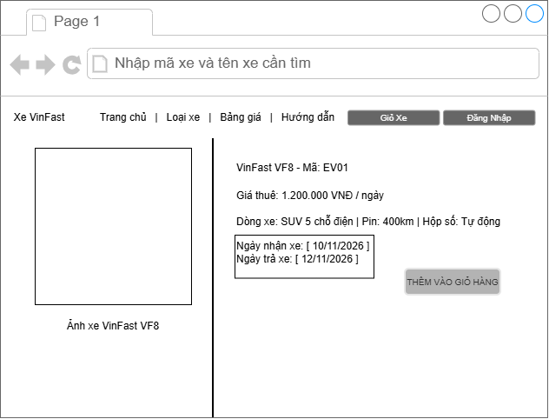Functional Description:
- FR-05 (View Vehicle Specifications): Displays high-resolution vehicle imagery alongside detailed technical specifications (vehicle line, battery capacity, driving range, transmission type) and daily rental pricing.
- FR-07 (Rental Duration Selection): Customers select pickup and return dates using an interactive calendar picker. The system automatically calculates total rental days and enables the "Add to Cart" button.
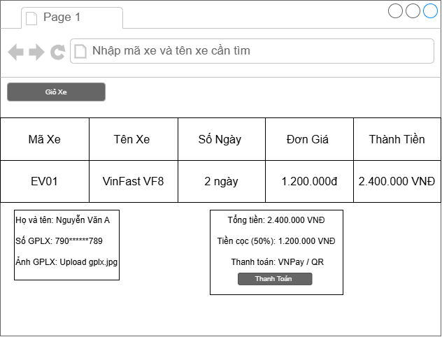Functional Description:
- FR-06 (Driver's License Verification): Customers input personal details (Full Name, License Number) and upload photos of their driving license for data verification.
- FR-08 (Online Deposit Payment): An order summary table lists Vehicle ID, rental duration, unit price, and total cost. Customers confirm a 50% deposit payment and select a payment gateway (VNPay or QR Code) to finalize the reservation.
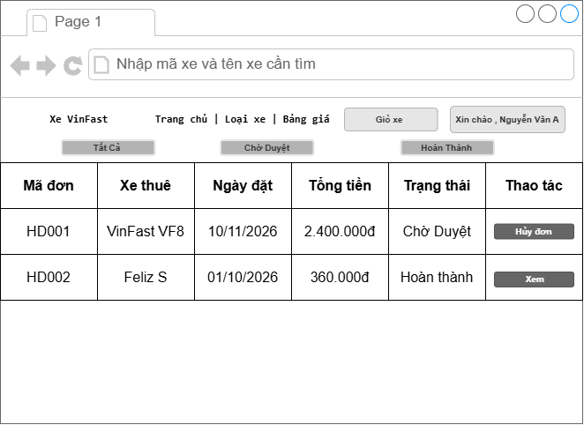Functional Description:
- FR-09 (Track and Cancel Orders): Allows users to review their complete personal booking history along with processing statuses such as Pending, New Order, or Completed.
- Provides quick status filter tabs and allows customers to manually cancel bookings for orders that are still pending vehicle handover.
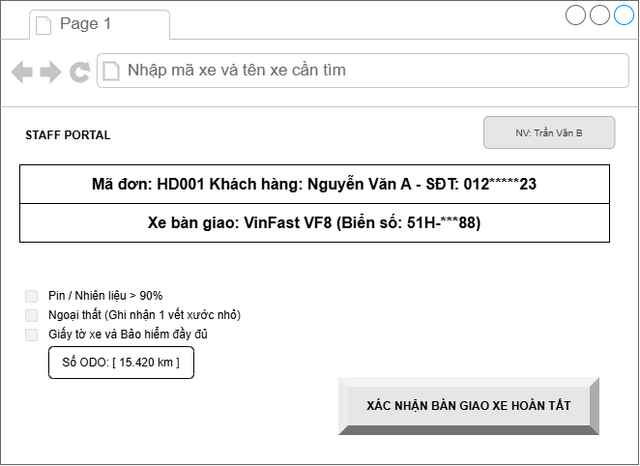Functional Description:
- FR-12 (Staff Handover Workflow): A dedicated portal for operation staff to execute vehicle pickup and return procedures at the station.
- Staff members search for booking IDs, complete safety checklist items (battery level > 90%, exterior condition check, insurance documents), and input the current odometer reading before clicking "Confirm Vehicle Handover Complete".
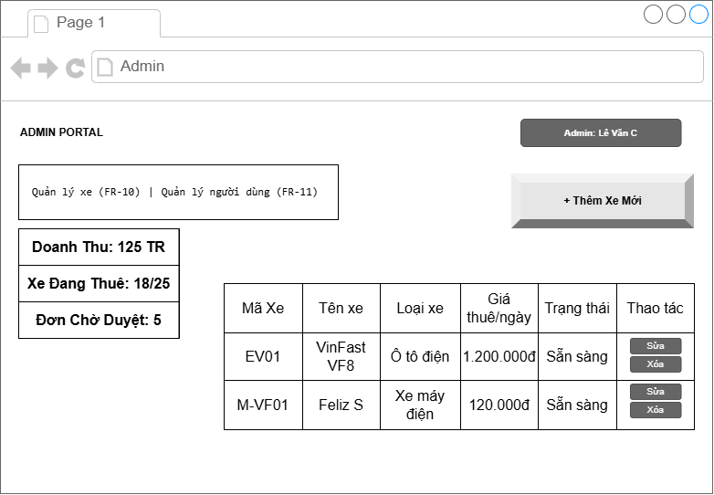Functional Description:
- FR-10 (Fleet Management and Pricing): Enables administrators to view all vehicles in the system, update status (Available or Rented), edit pricing, or add new vehicles to the fleet.
- FR-11 (User Account Management and Analytics): Provides quick operational metric cards (Total Revenue, Active Rentals, Pending Approvals) and manages user and staff role permissions.

